**Results:**

|  |  |  |  |
| --- | --- | --- | --- |
| **F1 Score** | **Accuracy** | **Precision** | **Recall** |
| 100 | 100 | 100 | 100 |

**Table 1.** Testing Result Analysis of Proposed Method in terms of distinct measures

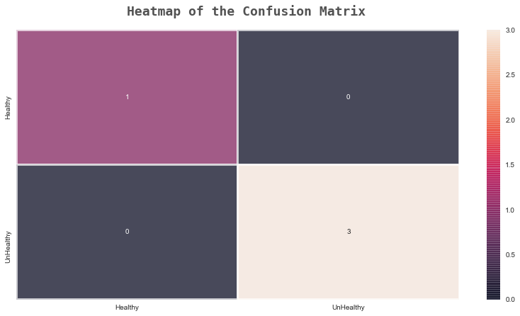

Figure x. Confusion Matrix

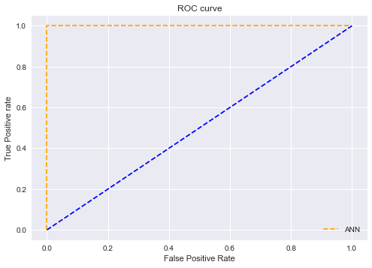

Figure x1. ROC Curve

**Conclusions**

In the work, we have developed an ANN (artificial neural networks) model for the various bearing fault segregation classification based on Park vector analysis of three-phase

stator currents. The experimental results indicate that the developed ANN model rendering 100% classification results for the dataset. It can be foreseen that the proposed method will enhance the reliability and accuracy of the methods used for the online detection and diagnosis of various bearing faults.